Testimonails

1..

Content: “I was seeking a property in Istanbul and was pleasantly surprised by the Casa Viva team. They explainedwith clarity all details and managed the actual sale negotiation wonderfully. Moreover,they were extremely responsive to every one of my queries, irrespective of how small. I will definitely recommend others.”

Name: Mohammad mosharaf hossen.

Photo: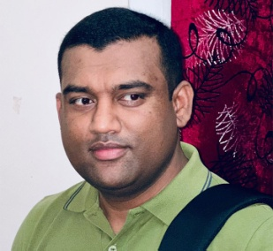

2..

Content: “In a country alien to us we found a friend, guide and a genuine advisor - we found Saad (Casa Viva Turkey) who made us feel right at home, helping us take the correct investment decisions. Well-versed with Turkish real estate market, immigration laws, we were helped through the whole process of property selection, purchase, registrationand renting assistance all rolled in one.

Name: Hidayat Pashwa

Photo: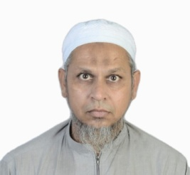

3..

Content: “Excellent service orientation, with friendly and responsive team that caters to every requirement of the customers.”

Name: Aqeel ahmed

Photo: 

4..

Content: “Casa Viva Turkey has been extremely helpful in our property hunt. Right from our property search to getting the possession, Casa Viva Turkey has managed everything seamlessly. They have guided us to invest in the right property to ensure higher rental yield while minimizing the investment. I am thankful to the team for their right guidance and support.”.

Name: Aman ibrahim fakih

Photo 

5..

Content: “The team at Casa Viva Turkey is simply amazing. We have been given a personalised assistance in our search for a property in Istanbul. Their team explained everything in great detail about properties in line with our requirements and budget. It is due their knowledge, effort and efficiency that we have been able to buy our dream home.”

Name: Aamir aabid peerzada

Photo: 

6..

Content: “After a long search for a reliable property consultant, I came across Mr Saad from Casa Viva Turkey. After proper guidance for property investment,he has been extremely quick in renting out the property within few days of my purchase. The USP of Casa Viva Turkey is that after the purchase of the house you can completely handover the property to them and they will manage to furnish the house beautifully while being economical.”

Name: Aleksandr12

Photo: 